Managed PoE Switch

⚙️ What is a Managed PoE Switch?
# Source: Chatgpt (GPT‑5 Mini) at [12/18/2025]
A Managed PoE Switch is a network switch that provides both:
- ✅ Power over Ethernet (PoE) — to deliver electricity and data over the same Ethernet cable to compatible devices (like IP cameras, VoIP phones, access points),
- ✅ Advanced network control and configuration — via a management interface (web, CLI, SNMP).
This makes it ideal for enterprise, campus, and professional-grade networks that need power delivery and fine-tuned control over traffic, security, and performance.

🔧 Key Features of a Managed PoE Switch
# Source: Chatgpt (GPT‑5 Mini) at [12/18/2025]
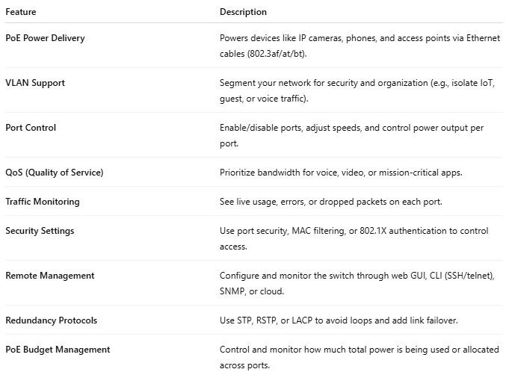

Feature | Description
PoE Power Delivery | Powers devices like IP cameras, phones, and access points via Ethernet cables (802.3af/at/bt).
VLAN Support | Segment your network for security and organization (e.g., isolate IoT, guest, or voice traffic).
Port Control | Enable/disable ports, adjust speeds, and control power output per port.
QoS (Quality of Service) | Prioritize bandwidth for voice, video, or mission-critical apps.
Traffic Monitoring | See live usage, errors, or dropped packets on each port.
Security Settings | Use port security, MAC filtering, or 802.1X authentication to control access.
Remote Management | Configure and monitor the switch through web GUI, CLI (SSH/telnet), SNMP, or cloud.
Redundancy Protocols | Use STP, RSTP, or LACP to avoid loops and add link failover.
PoE Budget Management | Control and monitor how much total power is being used or allocated across ports.

🏢 Example Use Case: Business Surveillance Setup
# Source: Chatgpt (GPT‑5 Mini) at [12/18/2025]
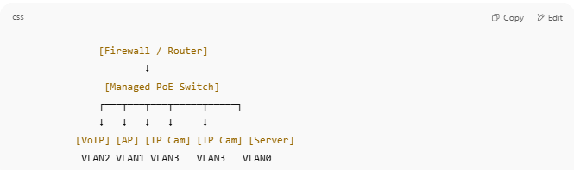

[Firewall / Router]
↓
[Managed PoE Switch]
┌───┬───┬───┬─────┬─────┐
↓ ↓ ↓ ↓ ↓
[VoIP] [AP] [IP Cam] [IP Cam] [Server]
VLAN2 VLAN1 VLAN3 VLAN3 VLAN0

- VLANs isolate voice, wireless, and surveillance traffic
- QoS ensures VoIP traffic gets top priority
- The admin can monitor port usage and remotely reboot a camera

🆚 Managed vs Unmanaged PoE Switch
# Source: Chatgpt (GPT‑5 Mini) at [12/18/2025]
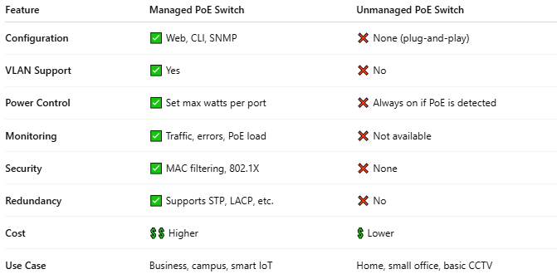

Feature | Managed PoE Switch | Unmanaged PoE Switch
Configuration | ✅ Web, CLI, SNMP | ❌ None (plug-and-play)
VLAN Support | ✅ Yes | ❌ No
Power Control | ✅ Set max watts per port | ❌ Always on if PoE is detected
Monitoring | ✅ Traffic, errors, PoE load | ❌ Not available
Security | ✅ MAC filtering, 802.1X | ❌ None
Redundancy | ✅ Supports STP, LACP, etc. | ❌ No
Cost | 💲💲 Higher | 💲 Lower
Use Case | Business, campus, smart IoT | Home, small office, basic CCTV

🔌 Power Standards Supported
# Source: Chatgpt (GPT‑5 Mini) at [12/18/2025]
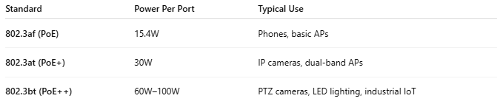

Standard | Power Per Port | Typical Use
802.3af (PoE) | 15.4W | Phones, basic APs
802.3at (PoE+) | 30W | IP cameras, dual-band APs
802.3bt (PoE++) | 60W–100W | PTZ cameras, LED lighting, industrial IoT

📦 Common Vendors & Models
# Source: Chatgpt (GPT‑5 Mini) at [12/18/2025]
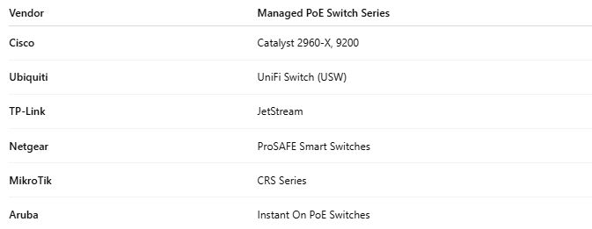

Vendor | Managed PoE Switch Series
Cisco | Catalyst 2960-X, 9200
Ubiquiti | UniFi Switch (USW)
TP-Link | JetStream
Netgear | ProSAFE Smart Switches
MikroTik | CRS Series
Aruba | Instant On PoE Switches

